

Project Initialization and Planning Phase

Date | 27 June 2026
Team ID | xxxx
Project Name | Smart Lender
Maximum Marks | 3 Marks

Define Problem Statements (Customer Problem Statement Template):

The Smart Lender – Loan Eligibility Prediction System is designed to address the challenges faced by both loan applicants and financial institutions during the loan approval process. Traditional loan evaluation methods are often time-consuming, require extensive manual verification, and may lead to inconsistent decisions. By understanding the needs, difficulties, and expectations of customers such as loan applicants, credit officers, and financial analysts, the project aims to develop an intelligent machine learning solution that provides fast, accurate, and reliable loan eligibility predictions. The following customer problem statements identify the key issues experienced by different stakeholders and form the foundation for designing an efficient, data-driven loan approval system.
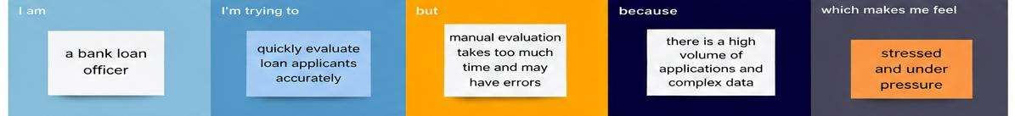

Problem Statement  (PS) | I am (Customer) | I’m trying to | But | Because | Which makes me feel
PS-1 | A salaried loan applicant with a stable income. | Get my loan approved quickly. | The loan approval process takes a long time. | Banks manually verify every application and supporting  document. | Frustrated and anxious about the delay.
PS-2 | A bank credit officer. | Evaluate loan applications accurately and  quickly. | Reviewing every application  manually is | There are many applications to | Overloaded and concerned about making incorrect decisions.

 |  |  | time-consuming and prone to errors. | process during peak periods.
PS-3 | A financial analyst in a bank. | Identify high-risk loan applicants before approval. | It is difficult to accurately predict loan defaults using only manual  assessment. | Applicant information is complex and risk factors are not always  obvious. | Concerned about approving risky loans and increasing financial losses.

